|  |  |  |  |
| --- | --- | --- | --- |
|  | **1.3.5 Practice: Analyzing a Production Possibilities Curve** | | Practice |
| Economics | Name: |  |
| Date: |  |

## **Section 1: Creating a Production Possibilities Curve**

**Complete items 1 through 5. Work through the pages of this activity if you need to review production possibilities curves. Feel free to jump back to the previous activities in the lesson if you need to review major concepts.**

1. Imagine products you might create in a given amount of time: poems, baked goods, online videos, movie reviews, video game mods, scarves, drawings, or anything else you can picture yourself making as part of a small, one-person business. Choose and describe two such products. They will be product 1 and product 2. (1 point)

2. What are the inputs — the scarce resources — required to create your two products? (1 point)

3. Come up with a set work period, such as one day or one week. State how many of product 1 you can make in that period if you create the product type exclusively. Then state how many of product 2 you can make in the same period if you work on *that* type of product exclusively. (1 point)

4. Fill out the table. Under the first column, list your two products. Then refer to question 3 to fill out columns A and E. Under column A, write down how many of product 2 you can create if you make zero of product 1. Under column E, write down how many of product 1 you can create if you make zero of product 2.

Then, in columns B through D, do your best to split the difference. Under column B, for example, if you make slightly fewer of product 1, how many of product 2 can you create in the same period? Estimate if needed. (2 points)

|  |  |  |  |  |  |
| --- | --- | --- | --- | --- | --- |
|  | **A** | **B** | **C** | **D** | **E** |
| Product 1: | 0 |  |  |  |  |
| Product 2: |  |  |  |  | 0 |

5. Now create your production possibilities curve, based on the information in the table you just filled out. Use the chart shown as a model, but note that your numbers and your curve will be different. Depending on the numbers you wrote in your table, your "curve" may even look more like a slant. (2 points)

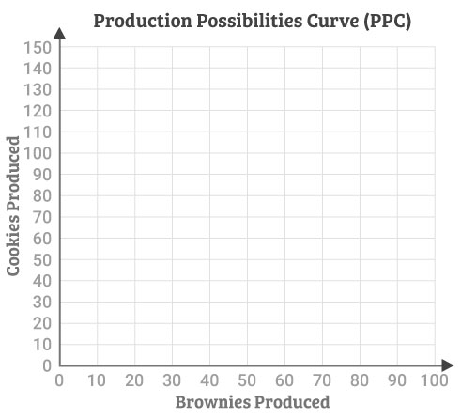

## **Section 2: Analyzing a Production Possibilities Curve**

1. In what way does your production possibilities curve demonstrate the concept of scarcity? Support your answer with examples from your imaginary business. (2 points)

2. In what way does your production possibilities curve demonstrate the concepts of trade-off and opportunity cost? Support your answer with examples from your imaginary business. (2 points)

3. What is the opportunity cost if you shift target production from one point on the curve to another? A shift from A to B, for example, might result in an opportunity cost of 5 of product 1. In the table, state the opportunity cost for each of the shifts listed. In addition to providing a number, be sure to specify which type of product is being given up. (1 point)

|  |  |
| --- | --- |
| **Shift** | **Opportunity cost** |
| From B to C |  |
| From A to C |  |
| From D to B |  |

4. Where on the production possibilities curve do the quantity of product 1 and the quantity of product 2 come the closest in number of products produced? (2 points)

5. Draw a vertical line from point B to the bottom of the graph. Then draw a horizontal line from point D to the left side of the graph. If your actual productivity was represented by the intersection of these two lines, what would it suggest about your efficiency? Under what circumstance might your productivity appear at this place on the chart, given what you know about your imaginary business and its resources? (2 points)

6. Come up with a number of products (including both product 1 and product 2) that is impossible given your limited resources. Where exactly would these two numbers intersect on the production possibilities curve? (2 points)

7. Describe at least two capital investments that would increase growth for your business. In other words, how might you expand the frontier of your production possibilities curve? Explain how your capital investments would help, and classify each investment by category: facilities, equipment, labor, marketing, or expansion. (2 points)

Copyright © 2022 Apex Learning Inc. Use of this material is subject to Apex Learning's [Terms of Use](http://www.apexlearning.com/Terms_of_Use_Customer_Websites.htm). Any unauthorized copying, reuse, or redistribution is prohibited. Apex Learning ® and the Apex Learning Logo are registered trademarks of Apex Learning Inc.

1.3.5 Practice: Analyzing a Production Possibilities Curve